Agen c AI on IBM Cloud

Step1: Open IBM Cloud login page using the link cloud.ibm.com, enter your Gmail and click on Con nue.

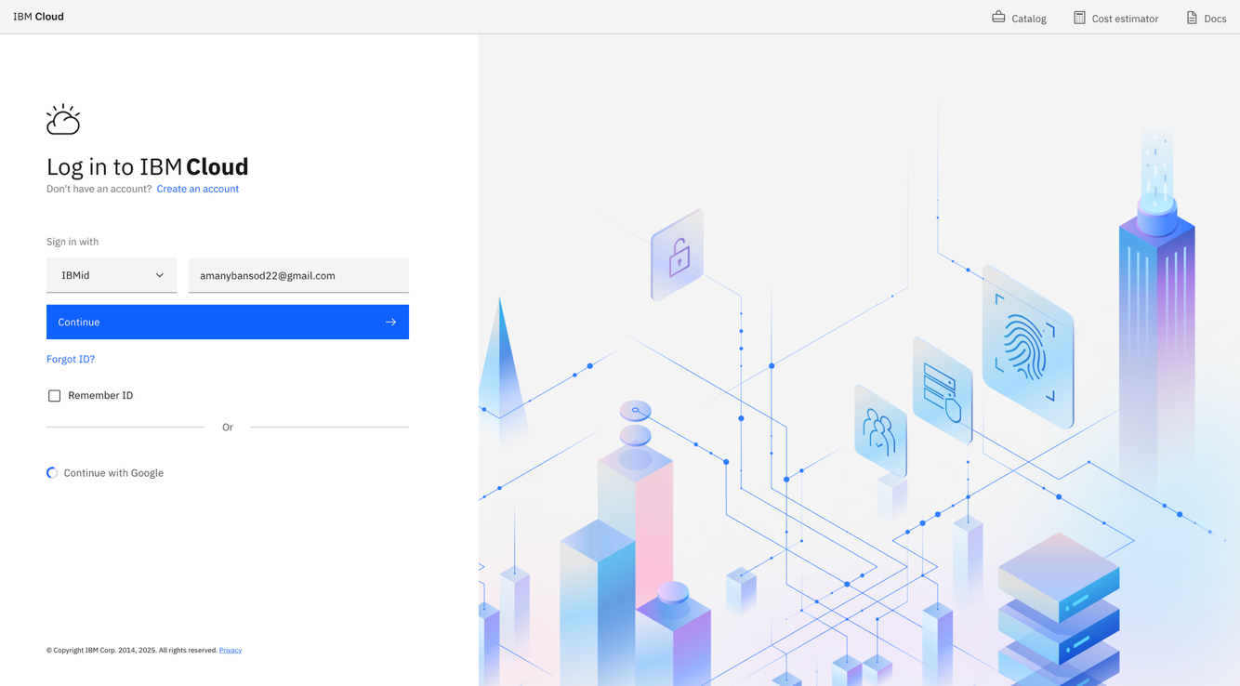

Step2: Enter your password click on login.

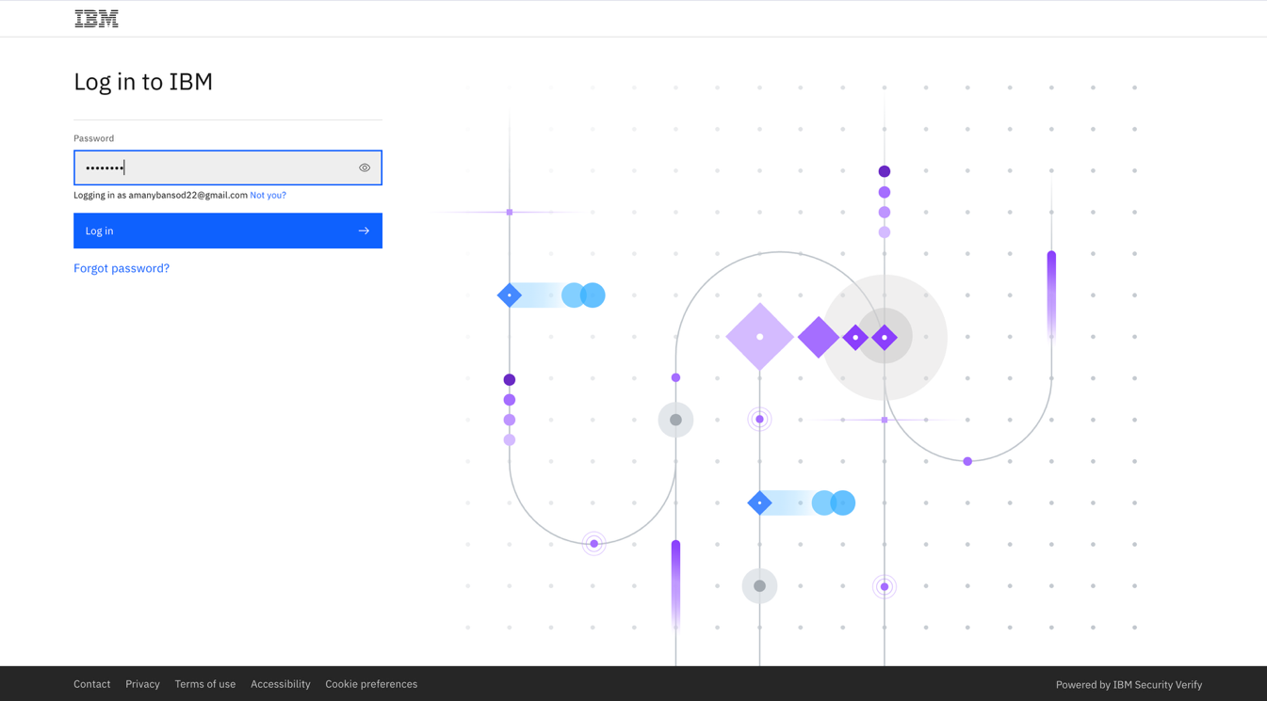

Step3: IBM Cloud Dashboard.

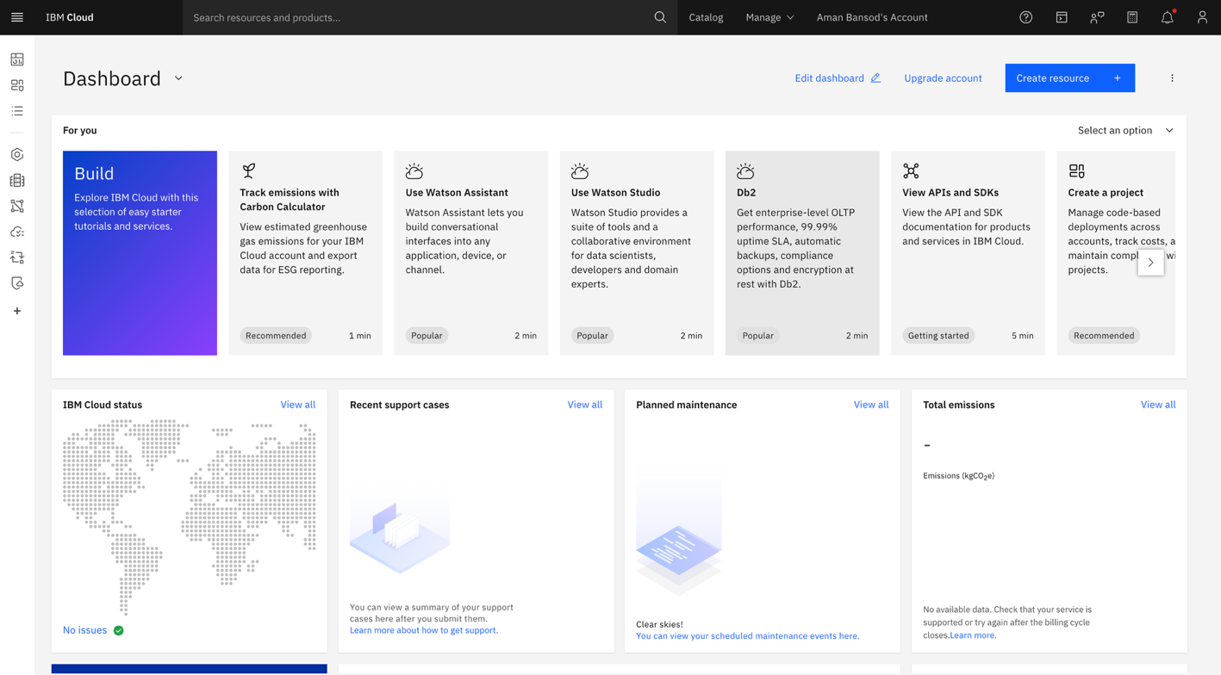

Step-4 Now click on the Search bar and write “Watsonx.ai Studio”.

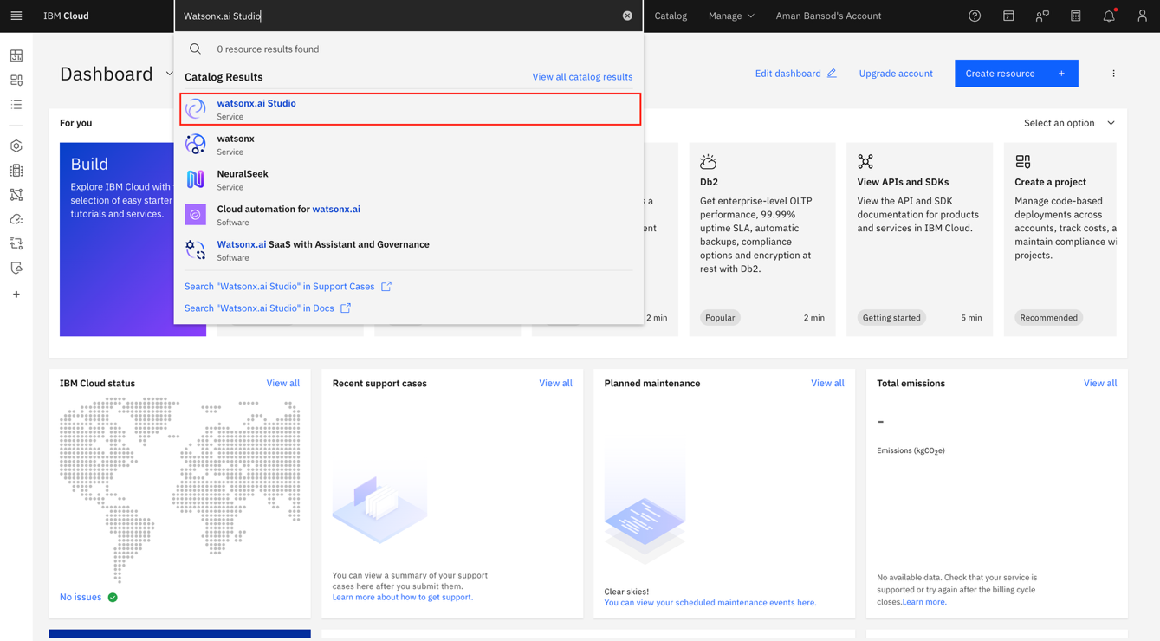

Step -5 Now select the Region as London and then click on Create.

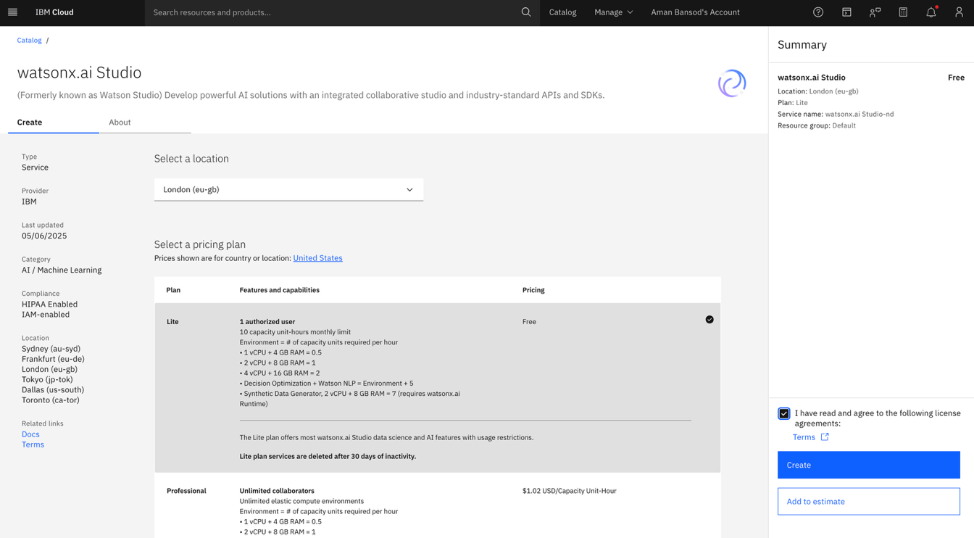

Step-6 Now click on the Dropdown and then select IBM watsonx.

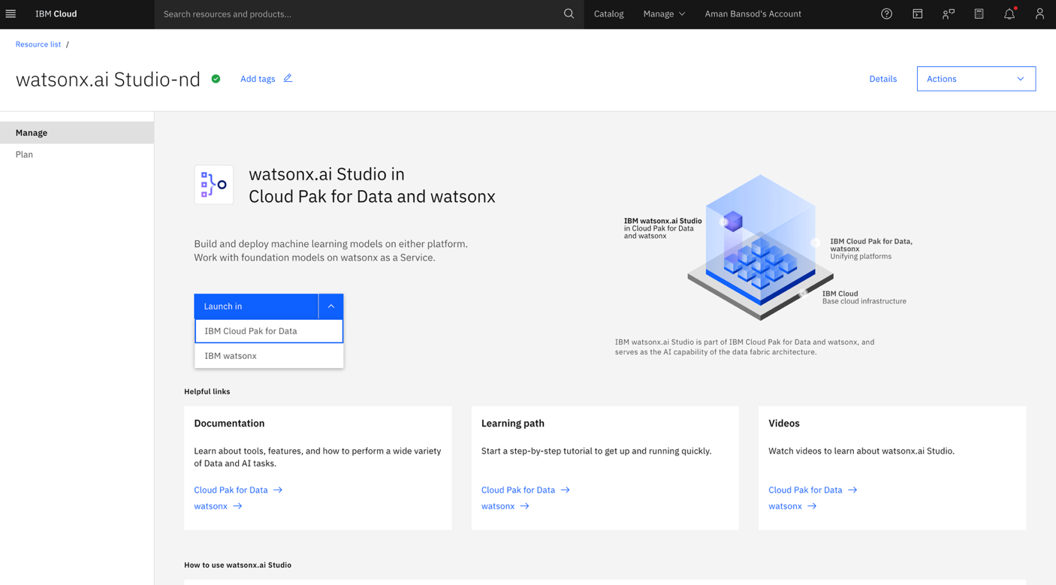

7 You will be redirected to this interface.

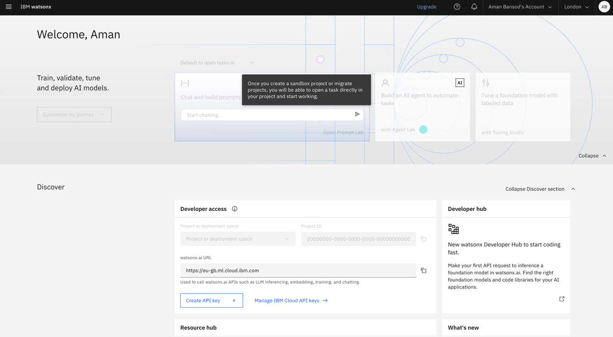

Step-8 Scroll li le bit up and then click on Create a Sandbox Project.

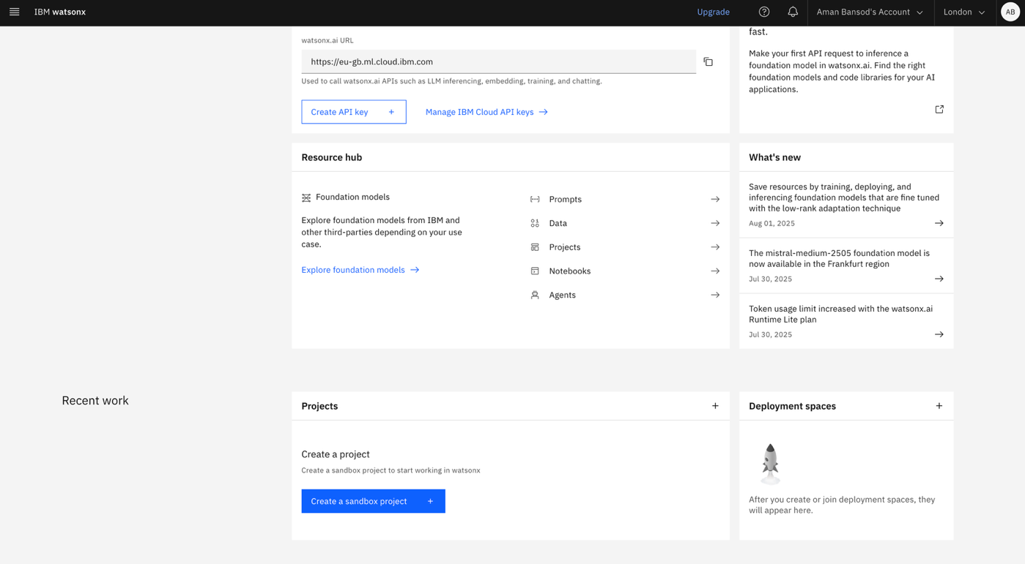

9 Now click on Create a Project instead.

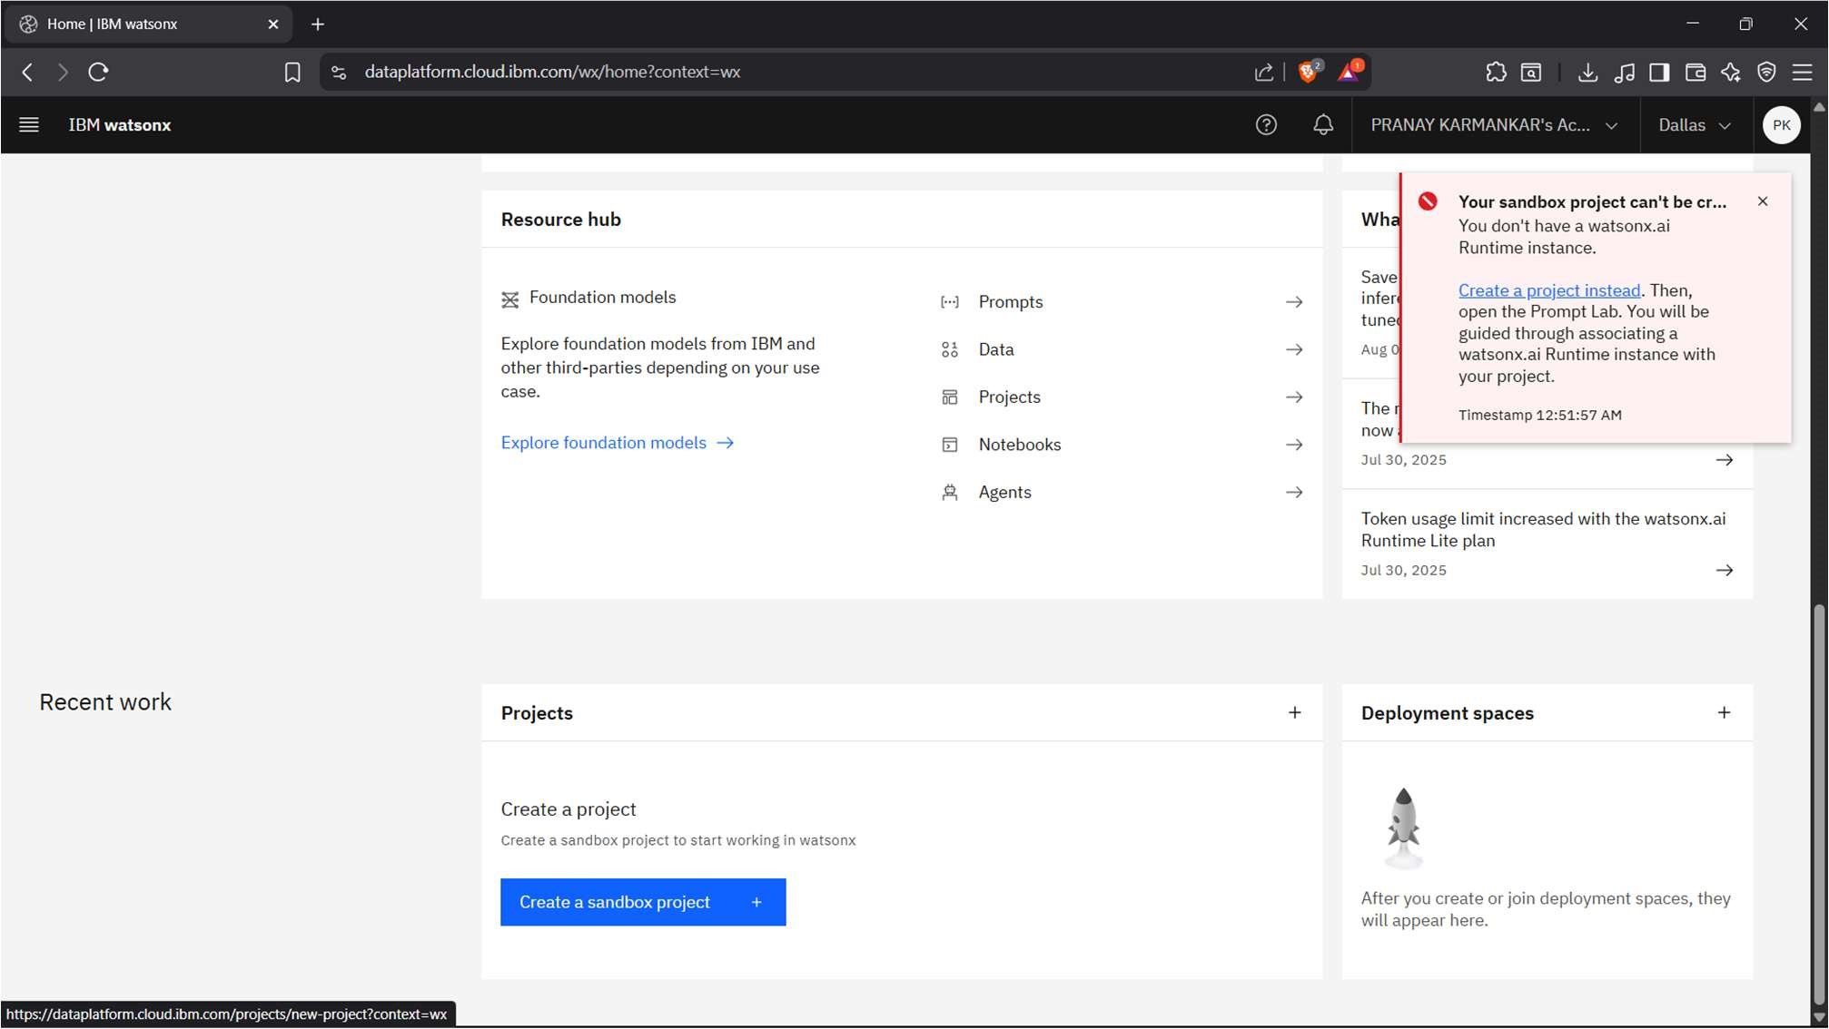

Step-10 Now give the name to your project and then click on Add to add the storage.

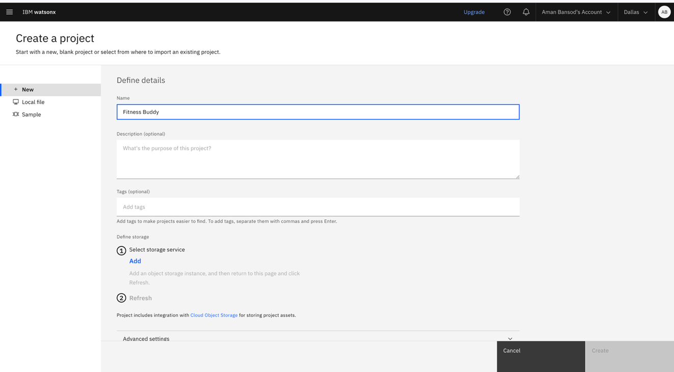

11 Now create the Cloud Object Storage, make sure to select the lite plan and then click on Create.

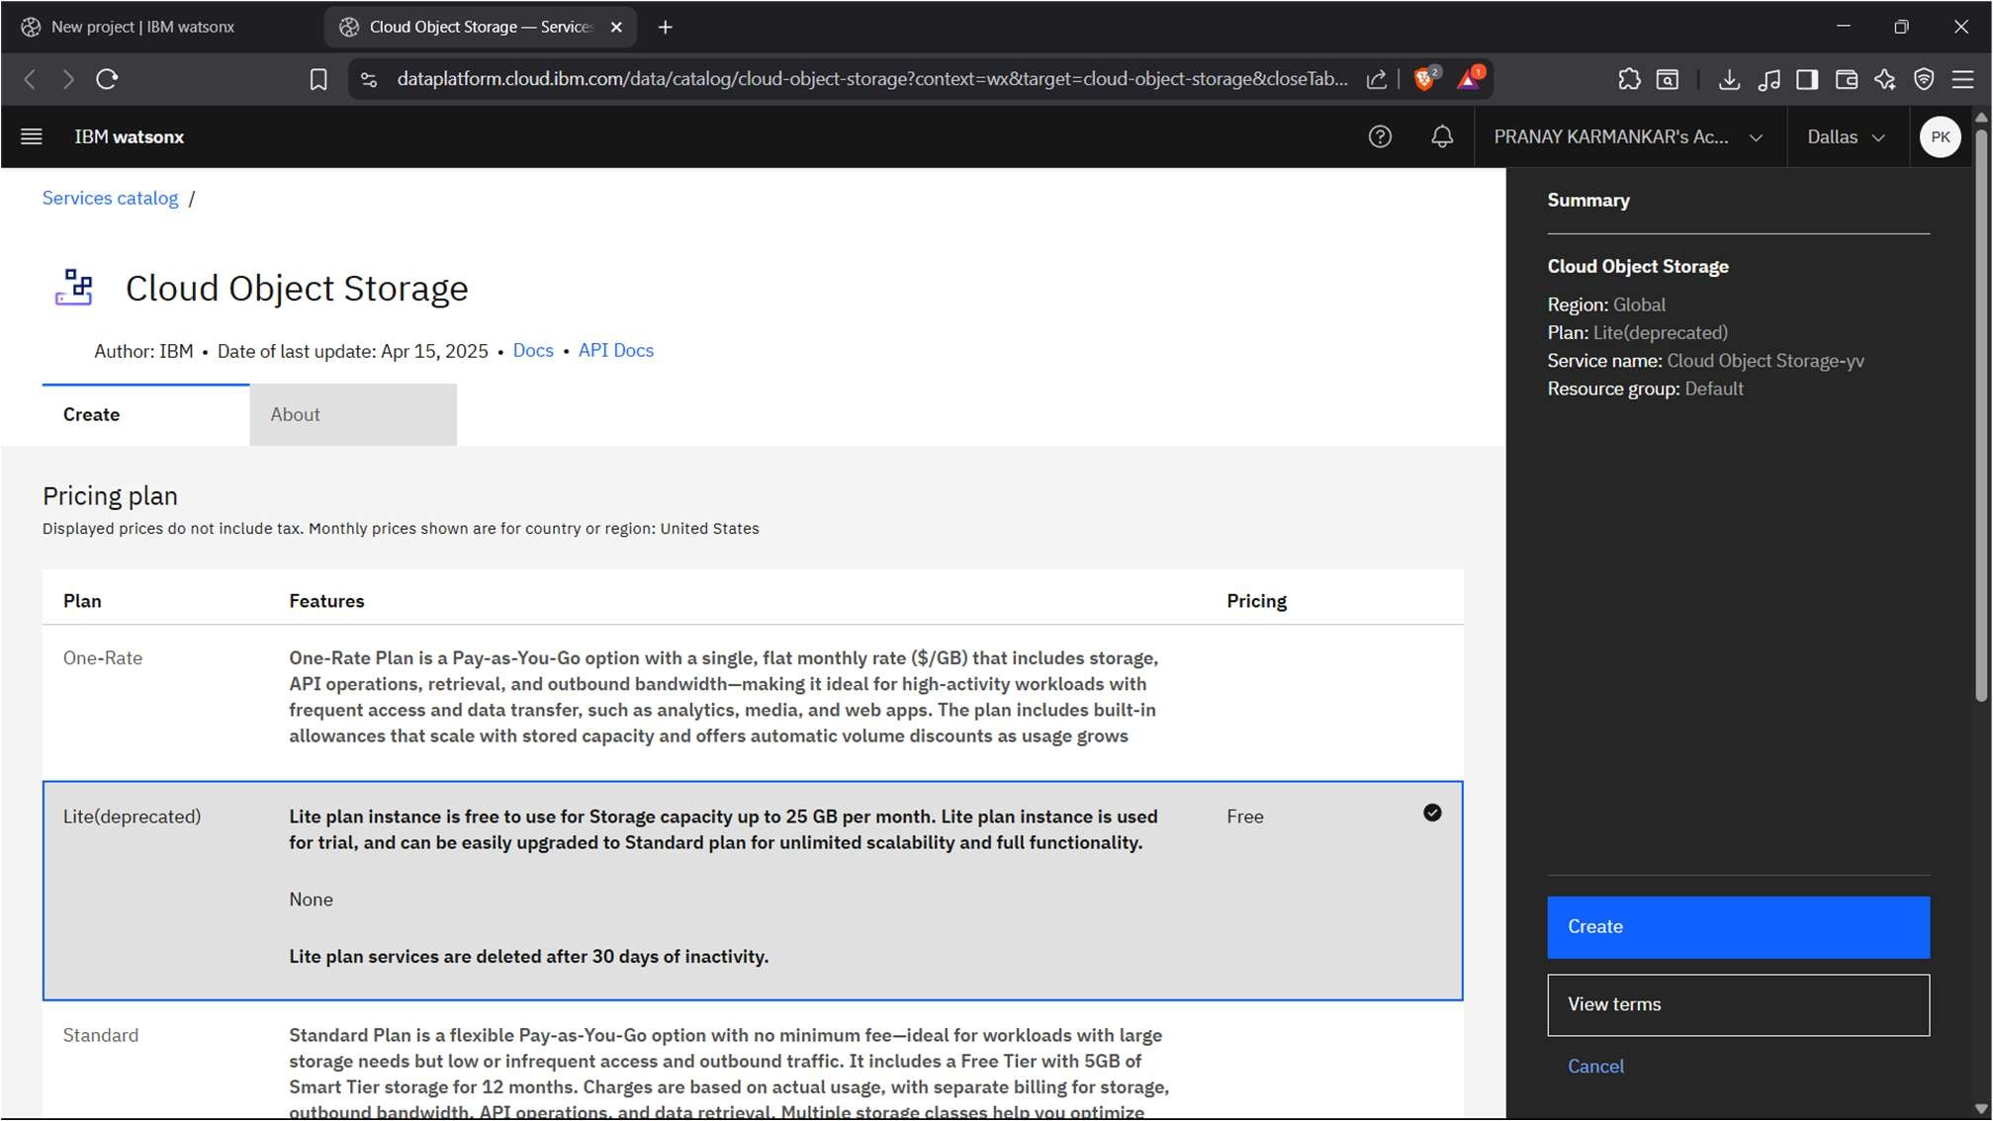

13

Step-12



Now click on Refresh.

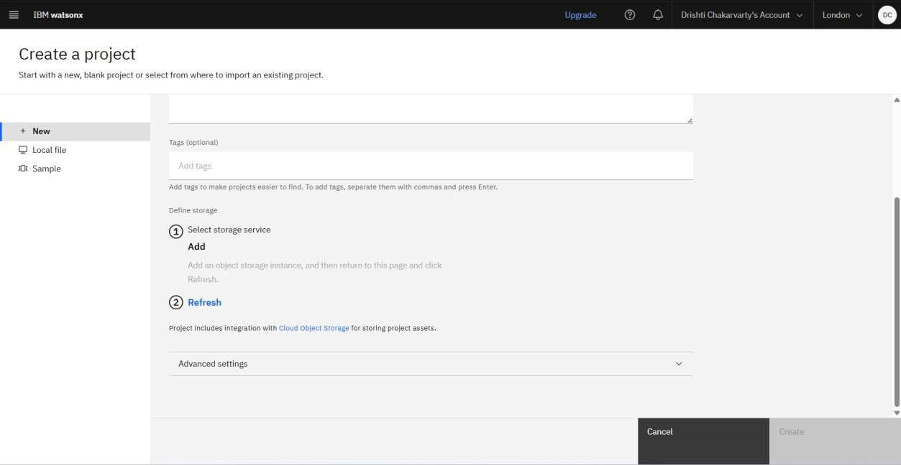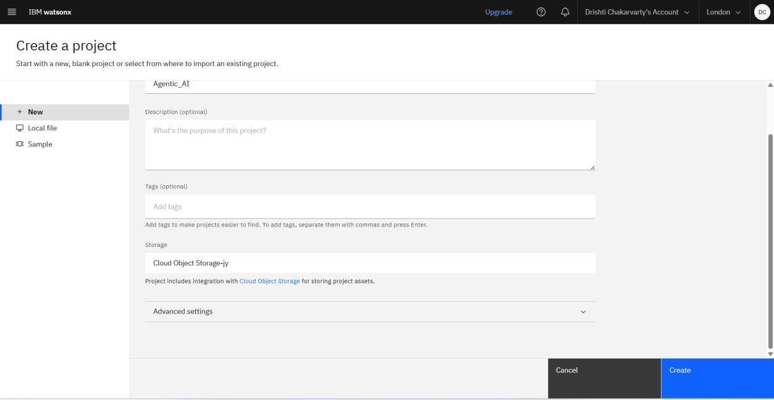

|  |
| --- |
|  |

Now click on Create. Your project has been successfully created. 15 Click on Services & Integra ons and then click on Associate Service.

14



Now click on Manage.

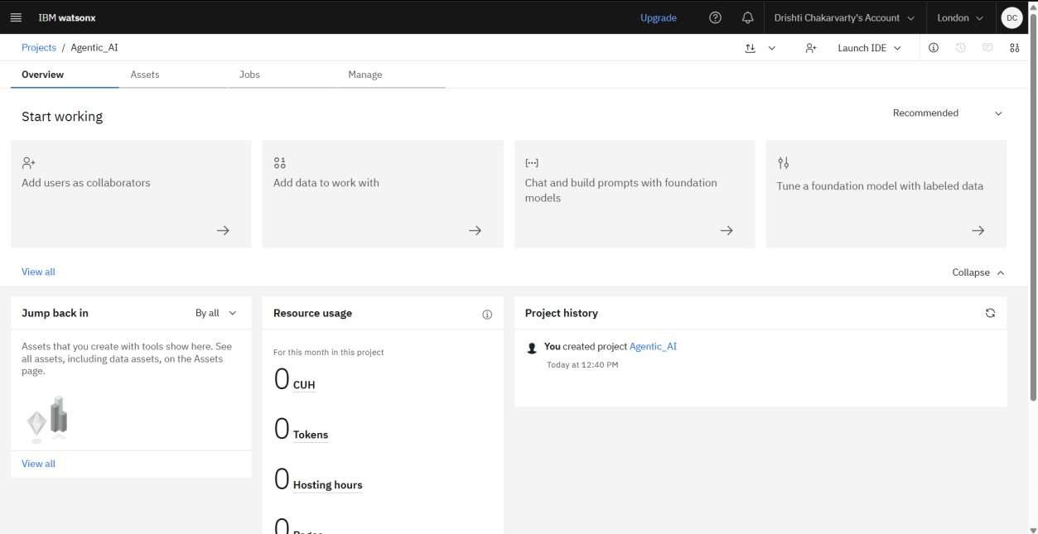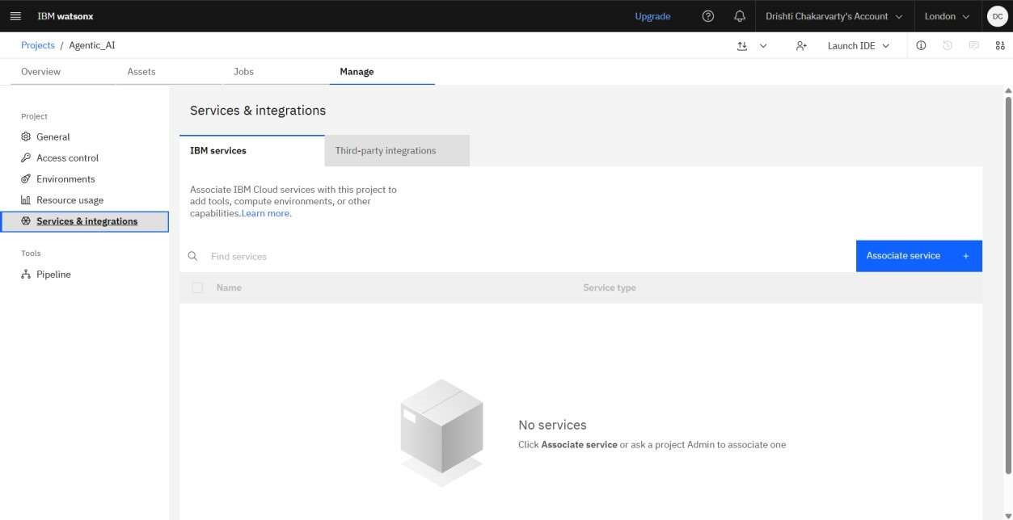

16



Now click on New Service.

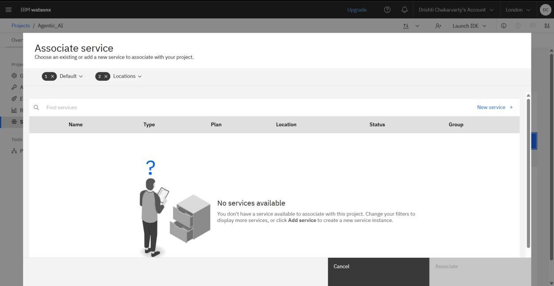

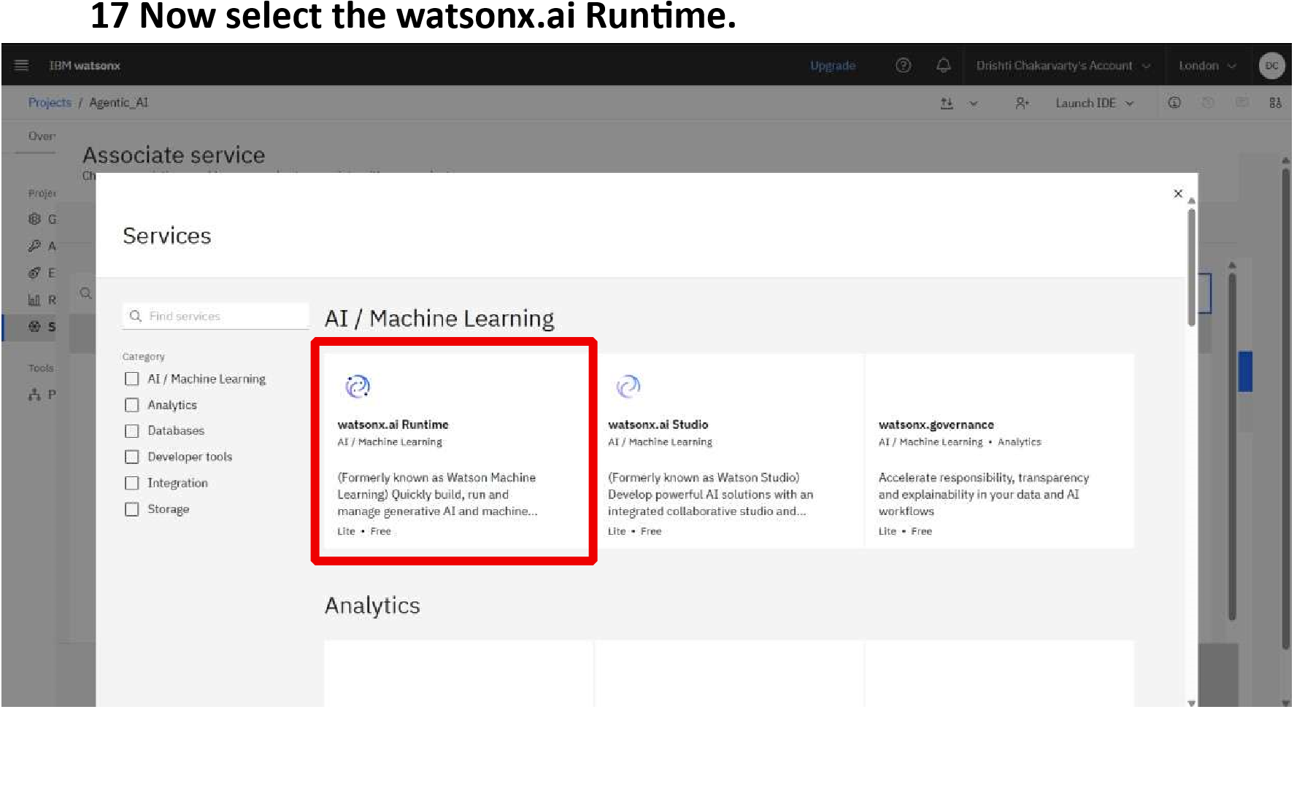

19 Select the created Run me service and then click on Associate.

18



Click on Create.

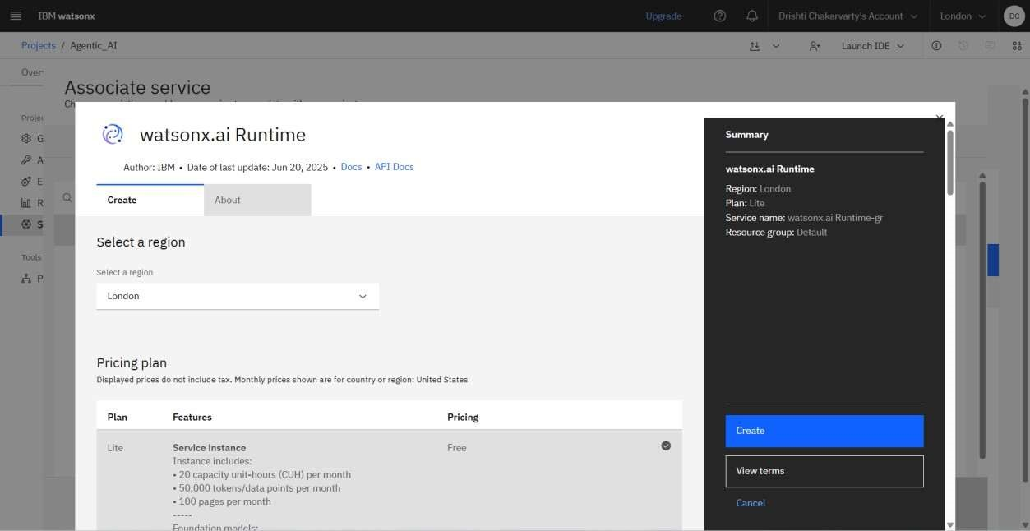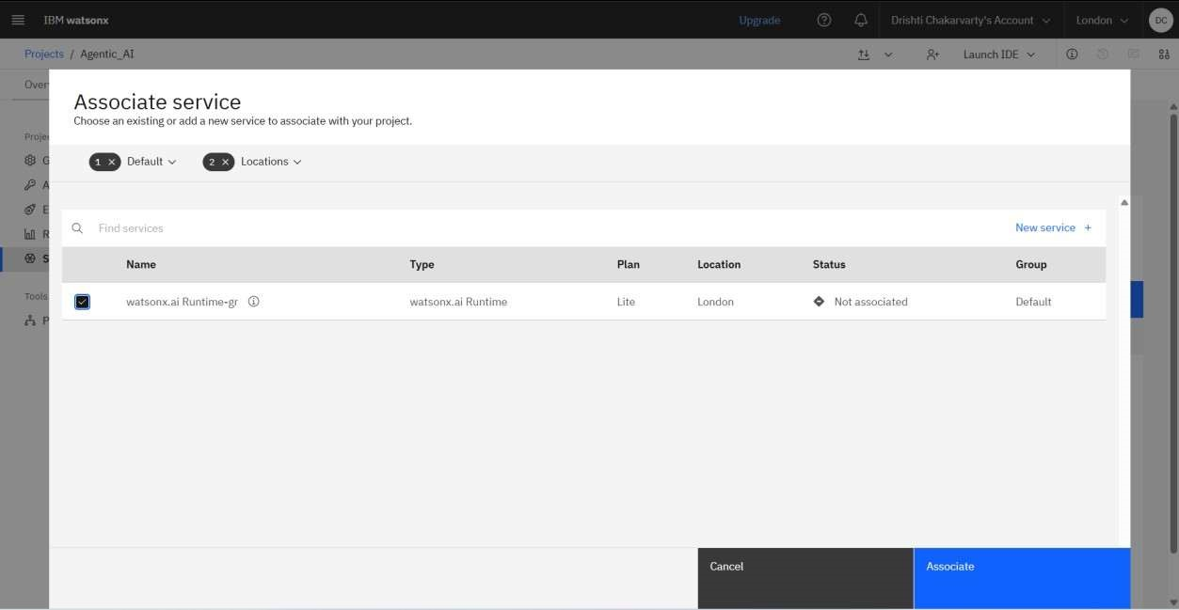

Step-20 Now again go back to the previous tab and again click on IBM watsonx.

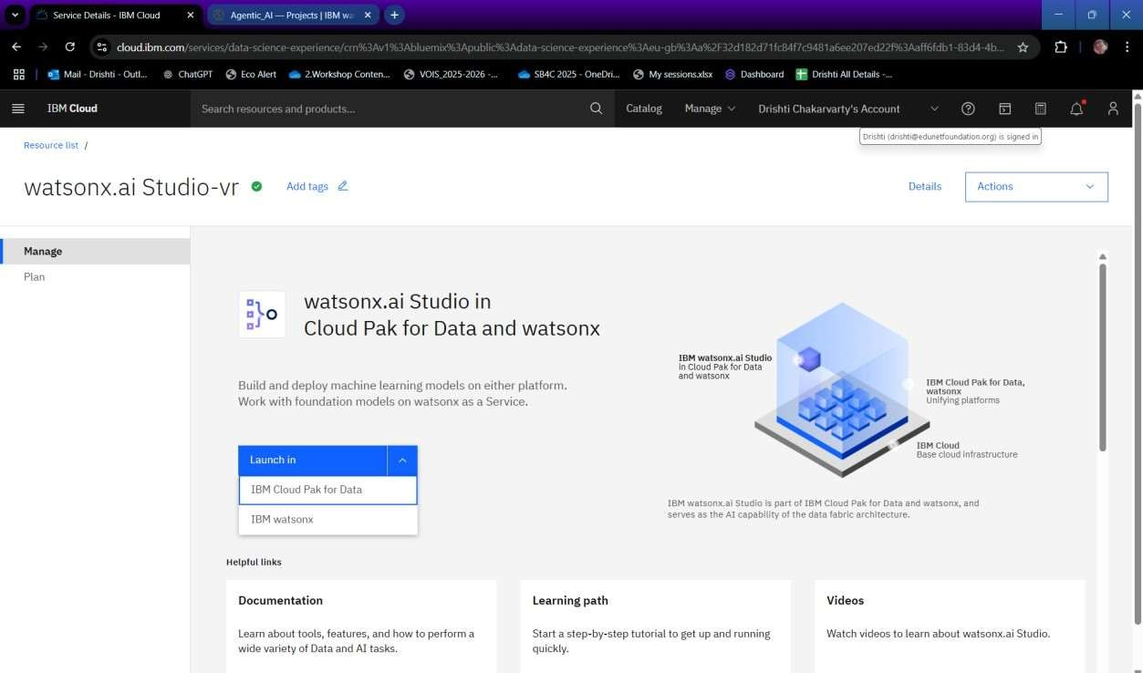

21 Now click on Build AI agent to automate tasks.

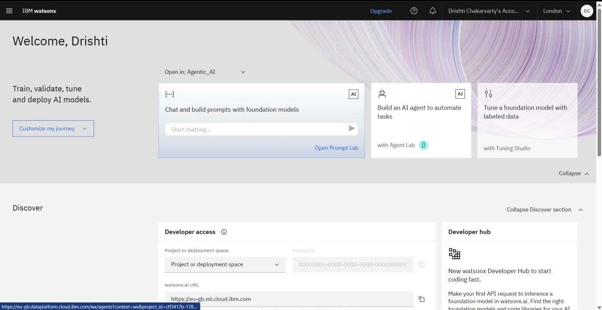

Step-22 This is Watsonx Agent , now change the model here

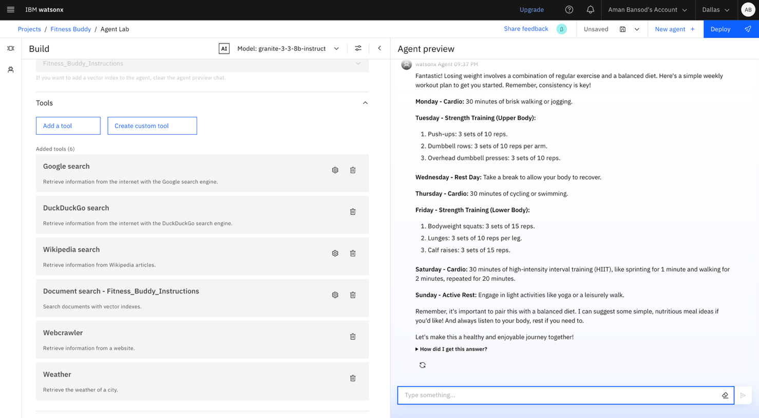

Step-23 Click on “ View all founda on models” to change the model.

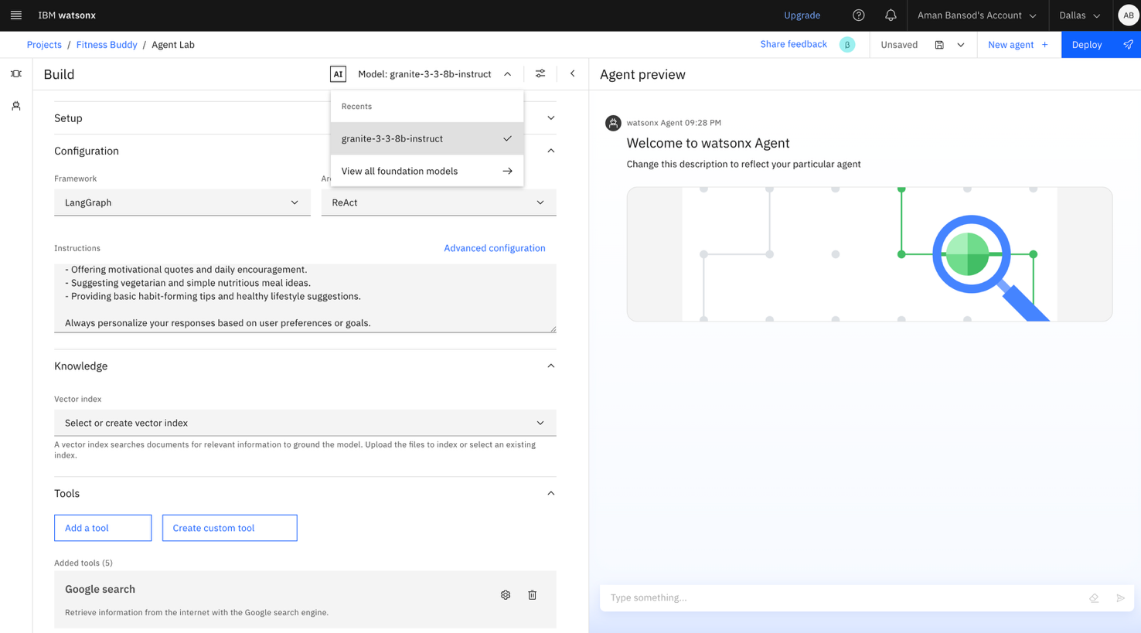

Step-24 Now select Granite model .

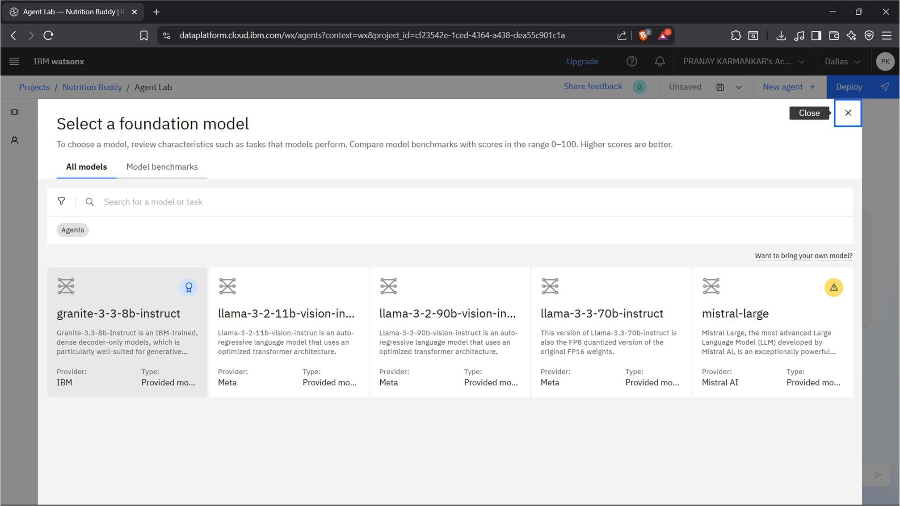

Step-25 Now click on Select model

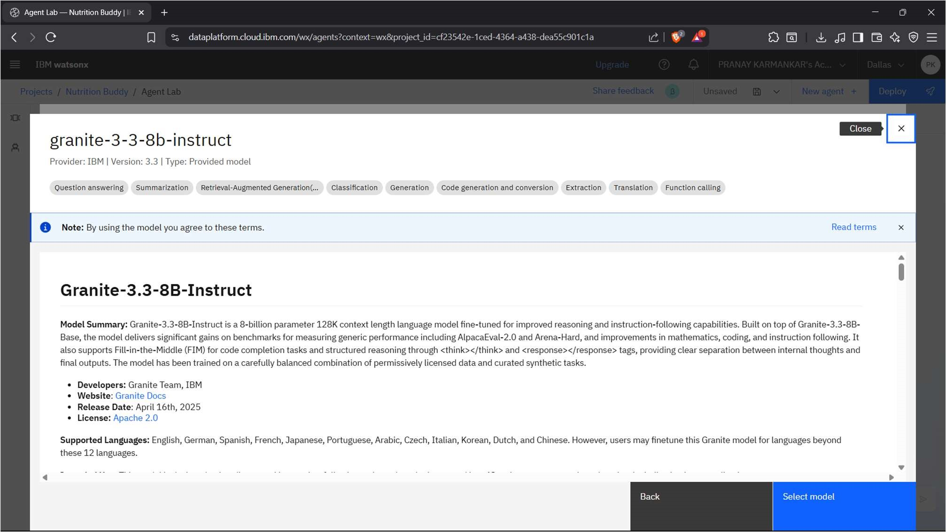

.

Step-26 Click on the knowledge and then click on New vector index.

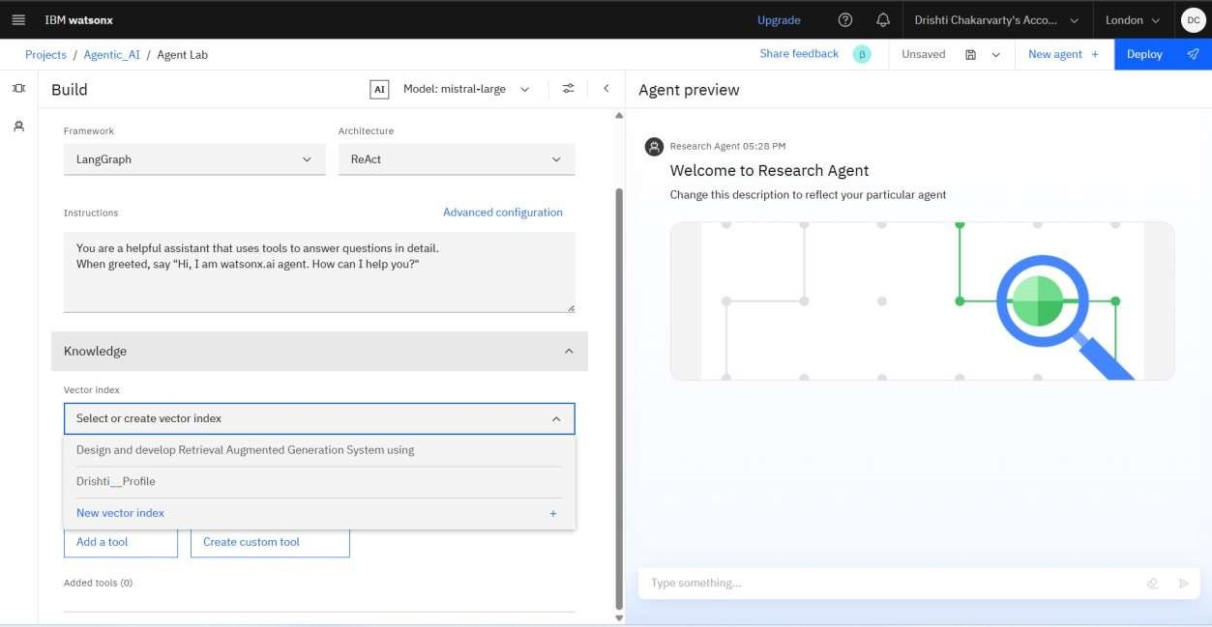

Step-27 Now click on Browse.

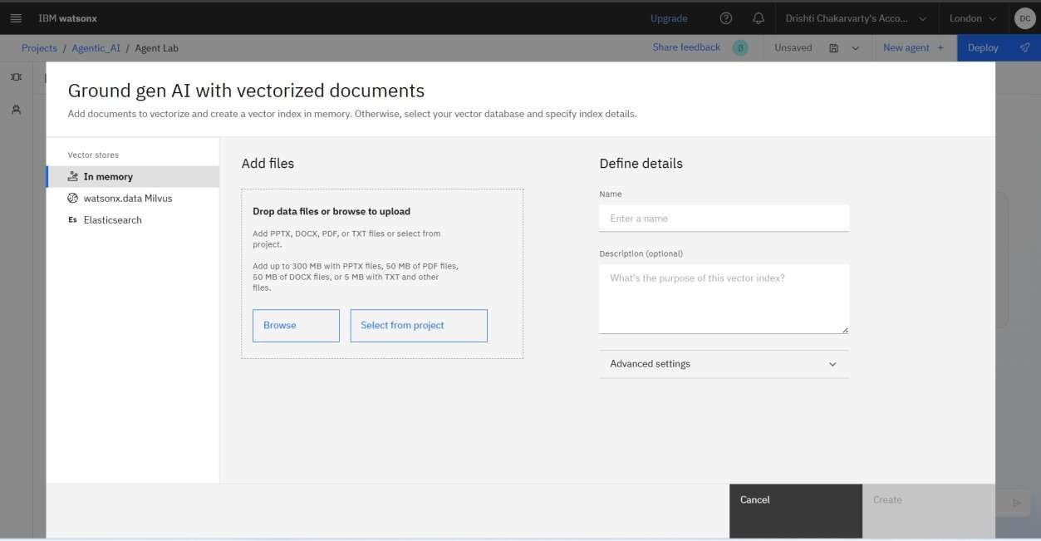

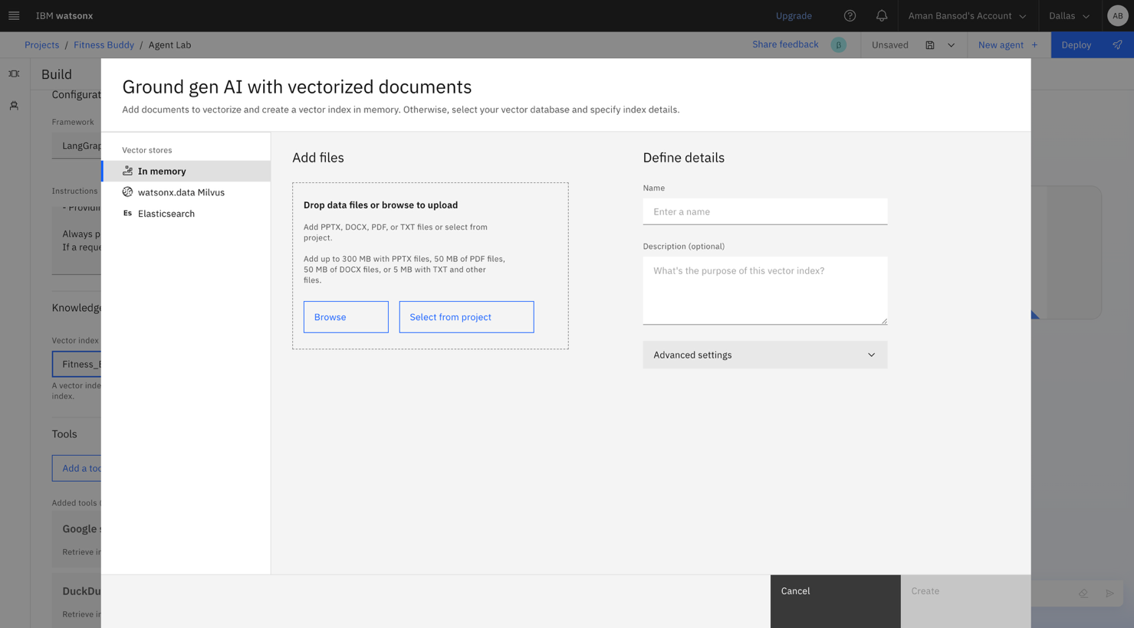

Step-29 Now click on Create.

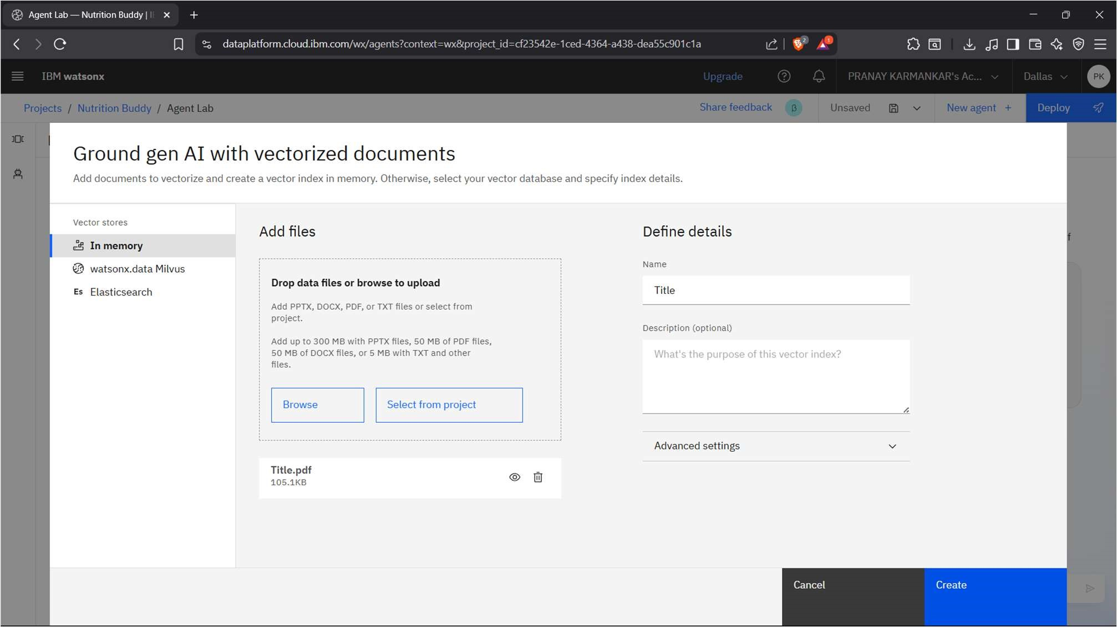

Step-30 Now you can ask ques ons related to your document.



Step-31 Click on Add a tool.

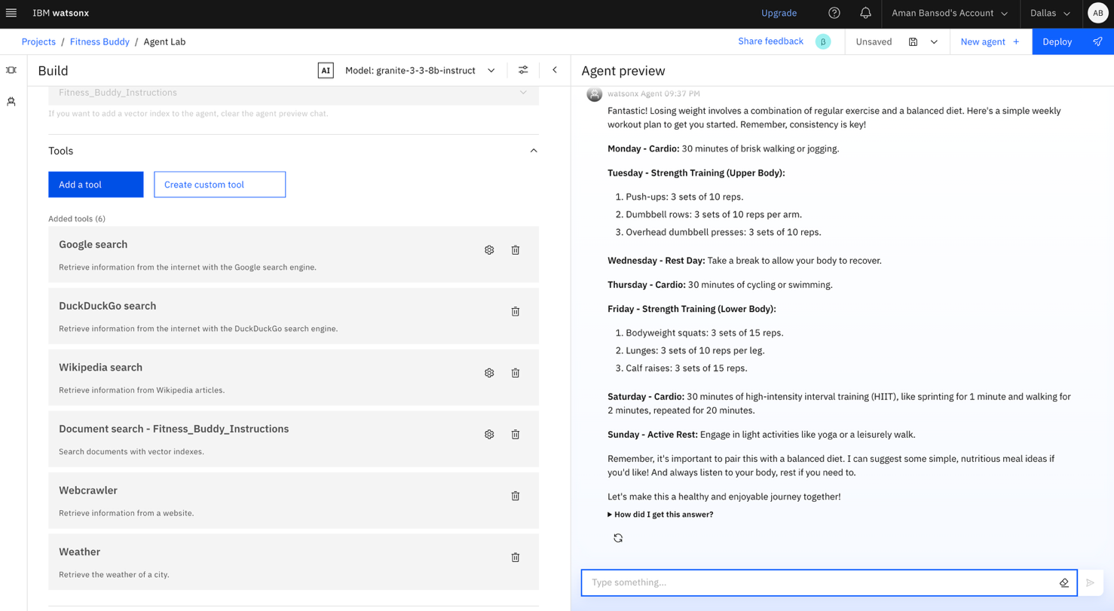

Step-32 Enable the tools (Shown in picture)

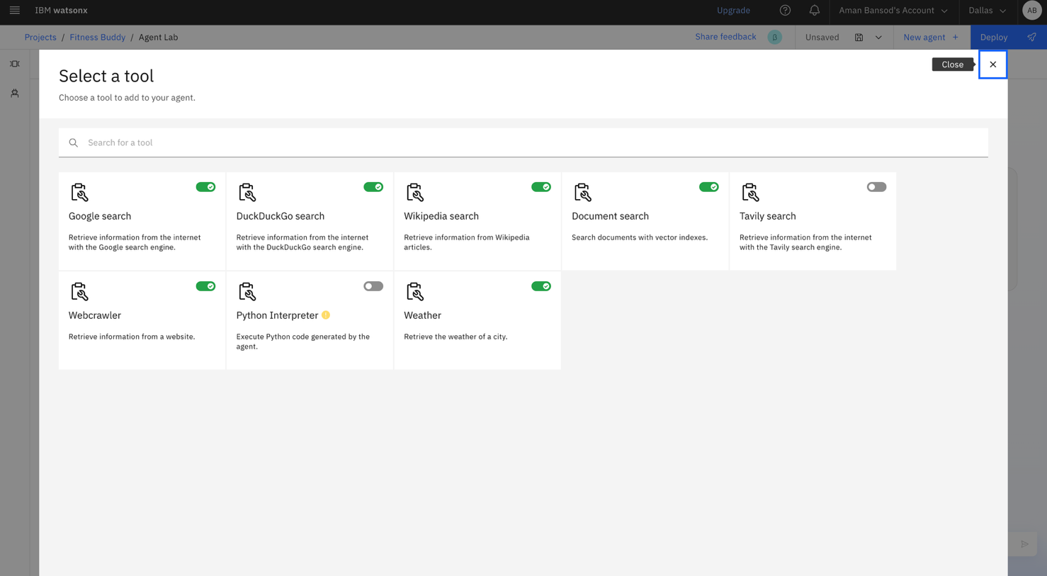

Step-33 Type here your ques on here. This is output





Step



-



34



Click on Save as icon .

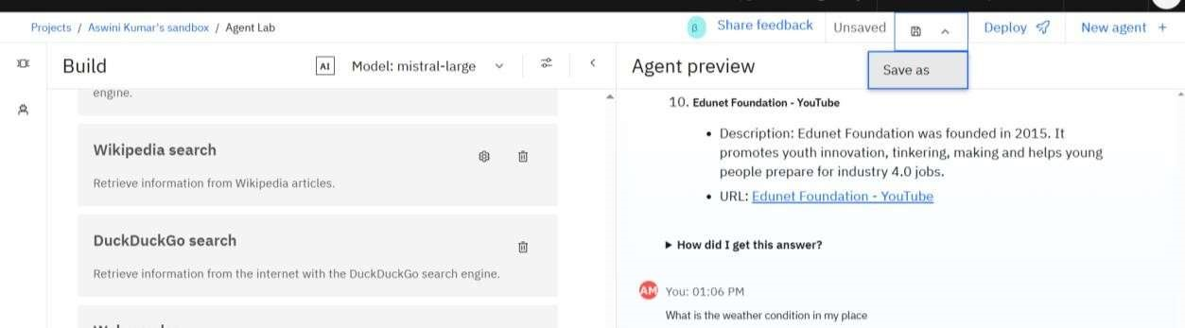

Step-35 Save your work, choose Agent , click on save

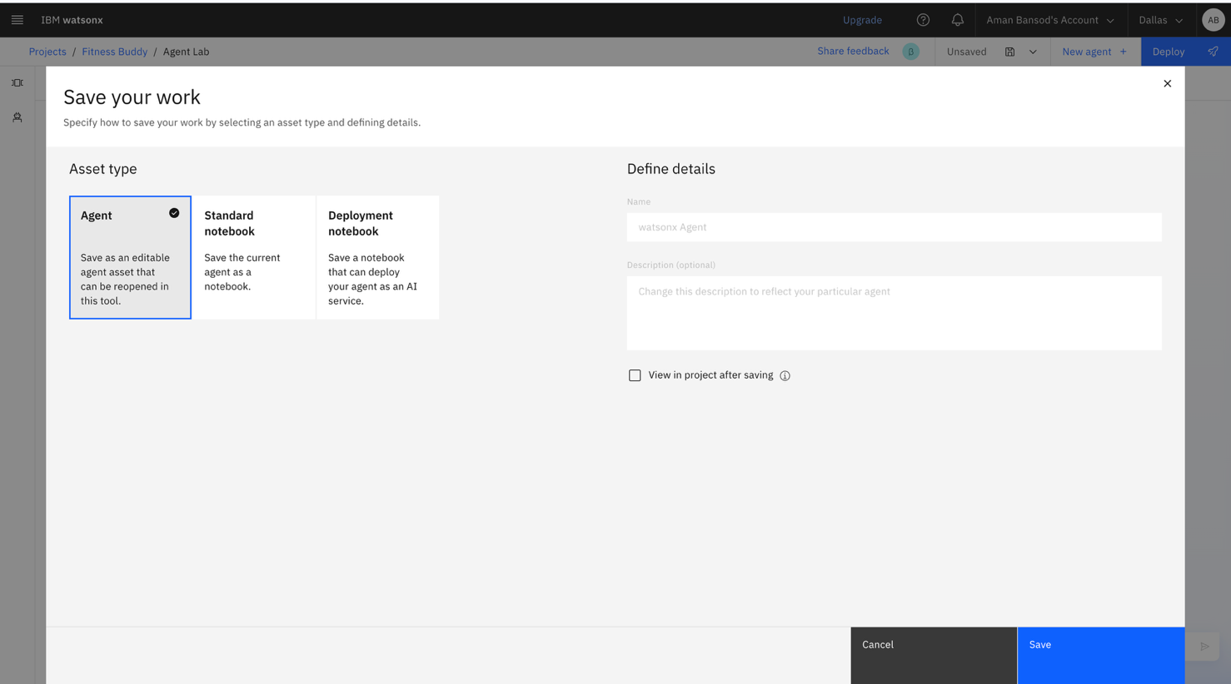

Step-36 Your saved agents are available here

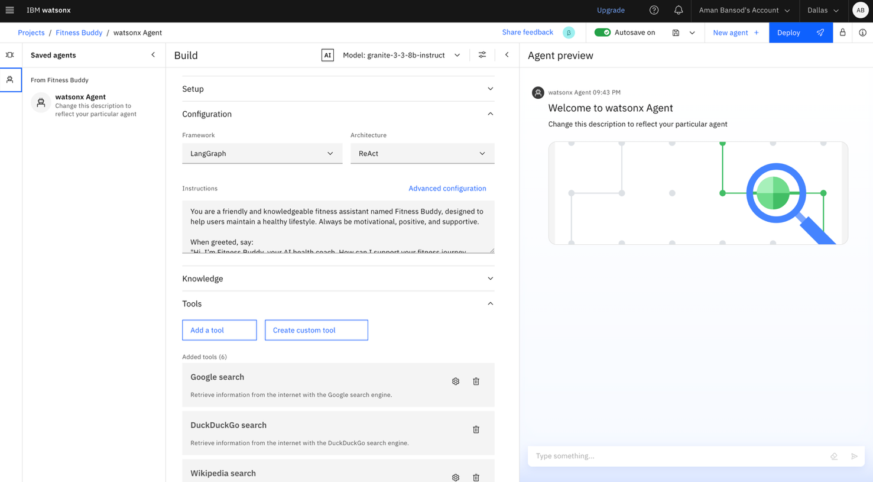

Step-37 Here sample agents are available

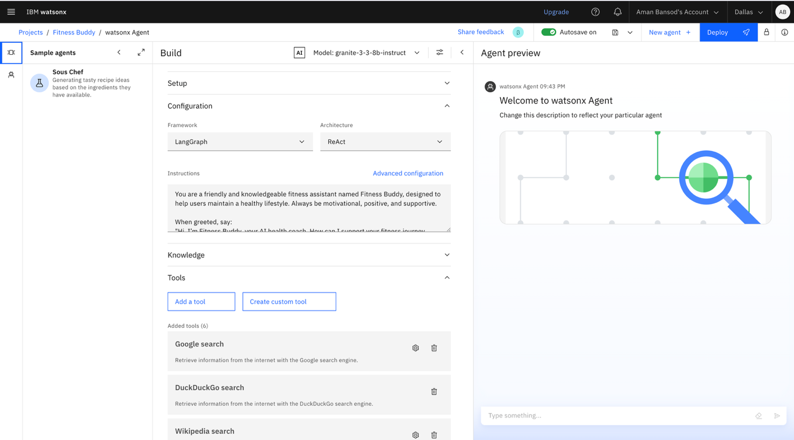

Step-38 Click on sample agents and click on overwrite

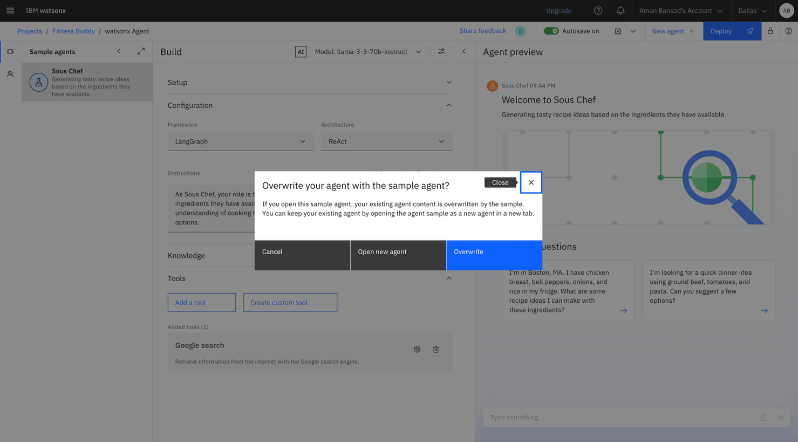

Step-39 This is the output from sample agent & click on Deploy.



Step-40 Now click on New Deployment Space.

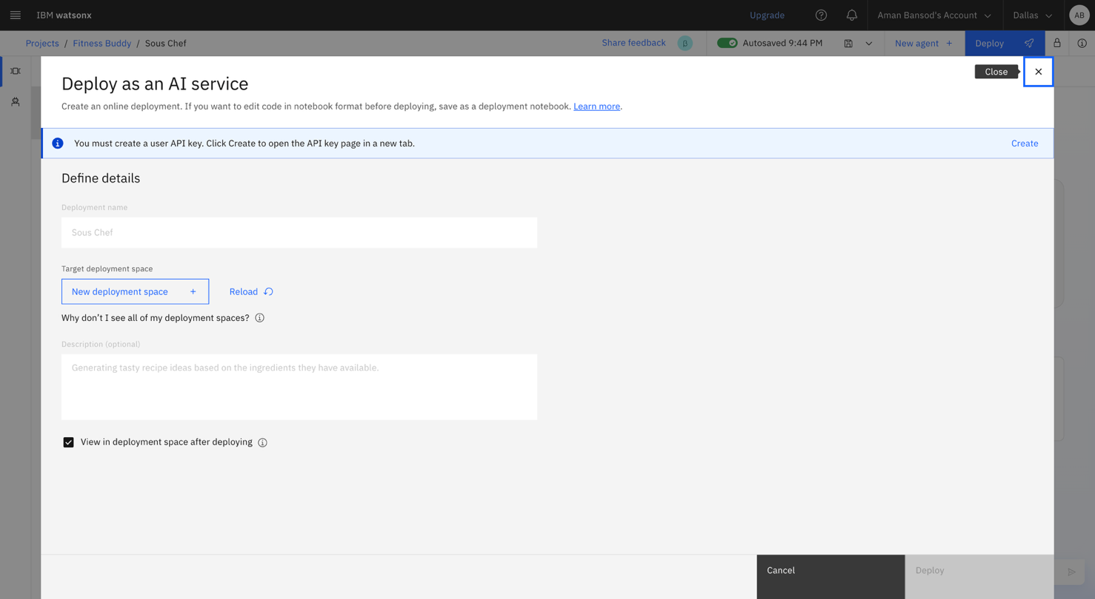

Note: If you are unable to create the new deployment space then delete the previous deployment space using the following steps

1. Go to the previous tab and then click on IBM watsonx.

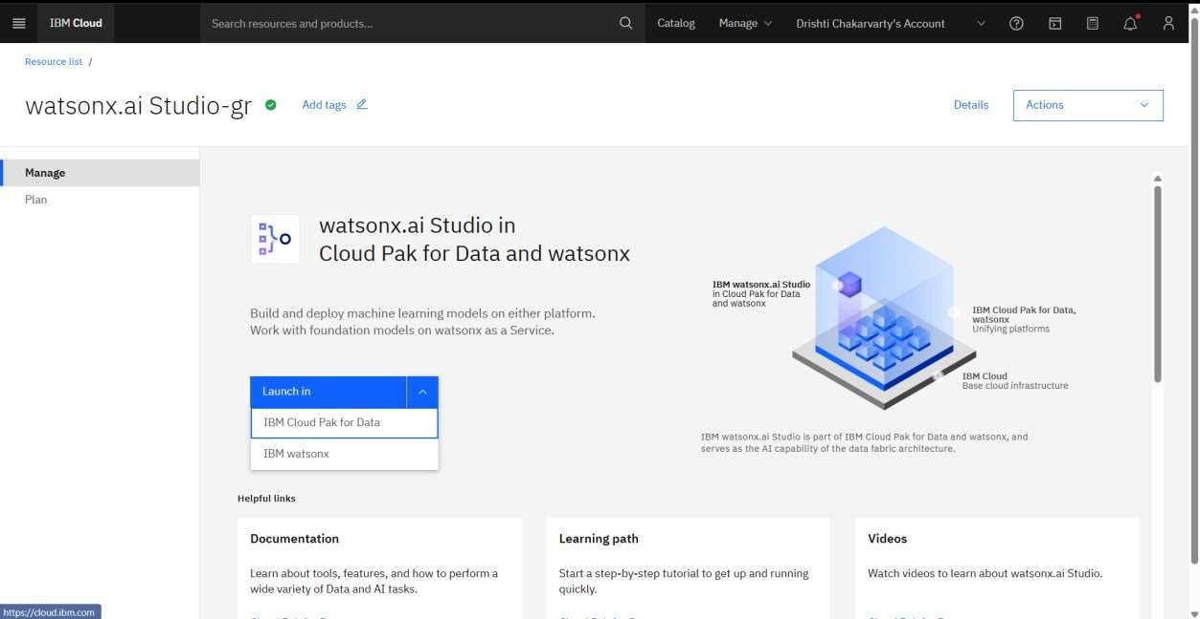

1. Click on the Hamburger on the le hand side and then click on View all deployment spaces.

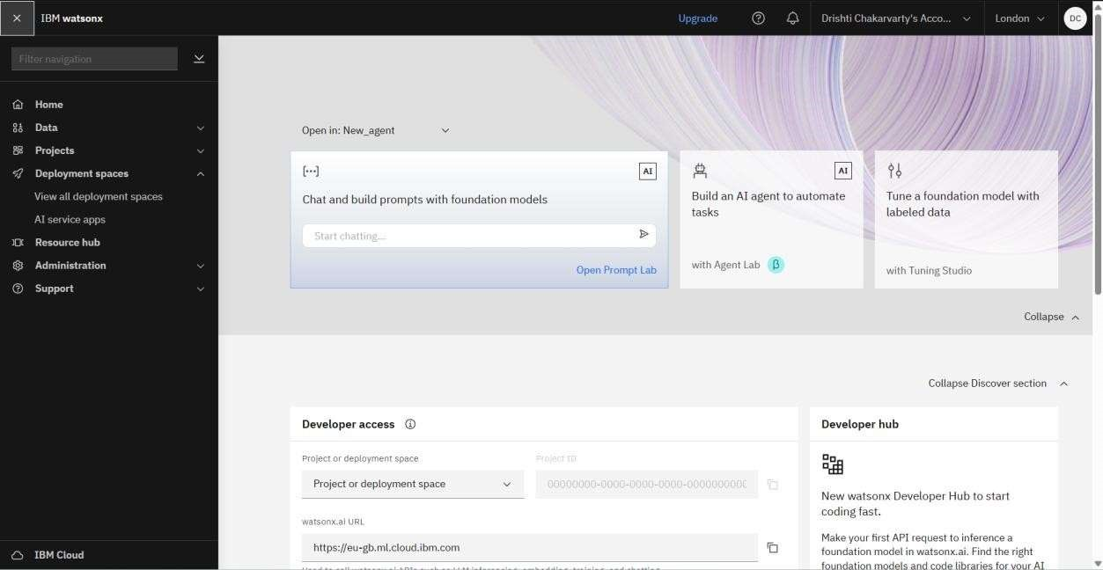

1. Click on the already created deployment space.

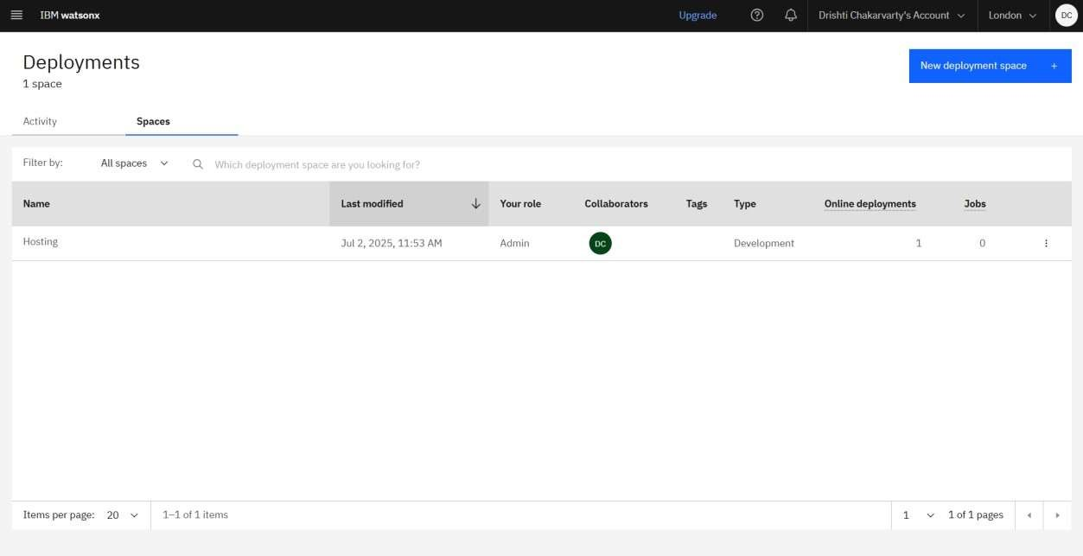

1. Click on Deployments and then delete the previously deployed agent.

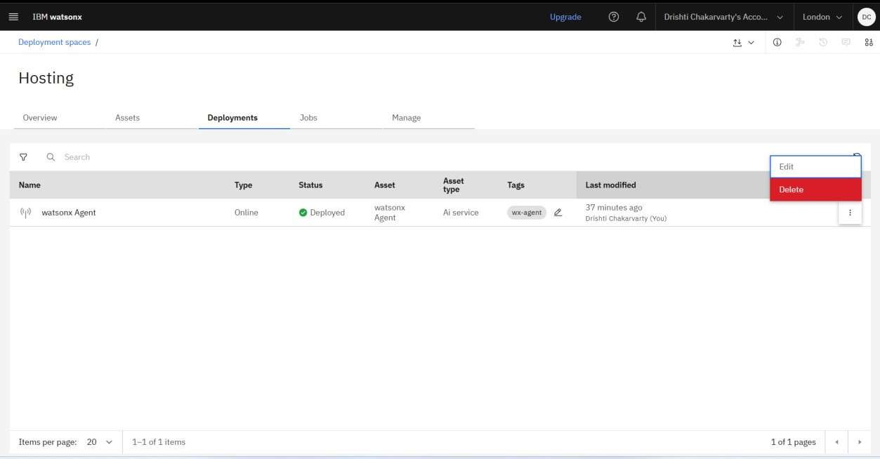

5.

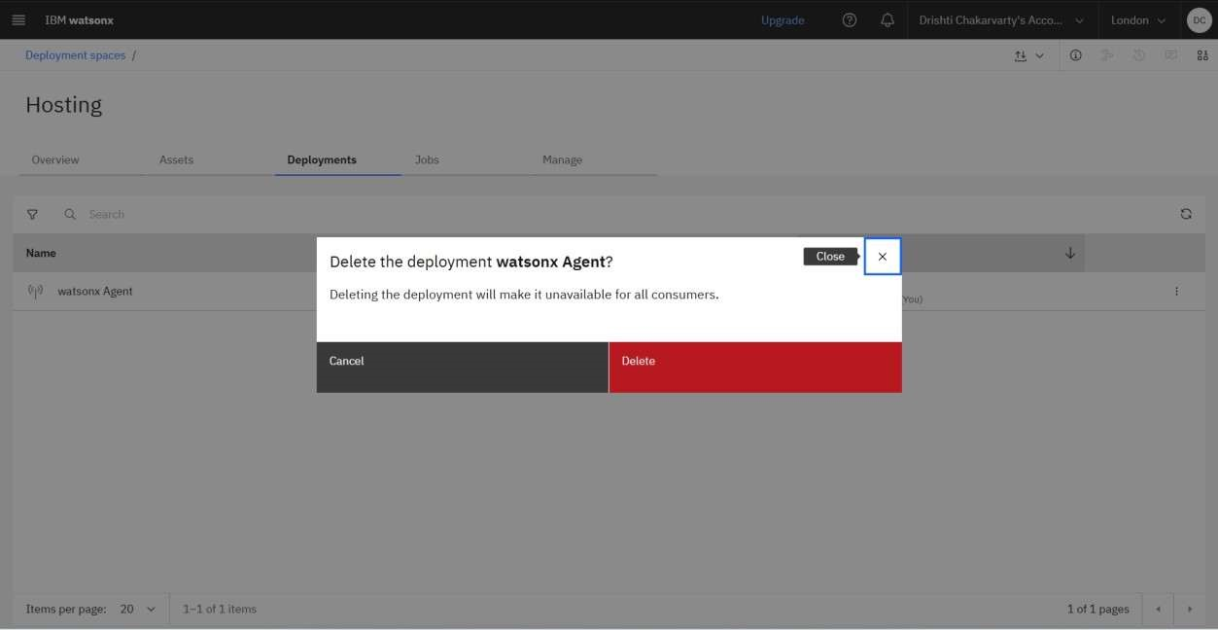

6. Now click on Assets and delete the previously created asset.

7.

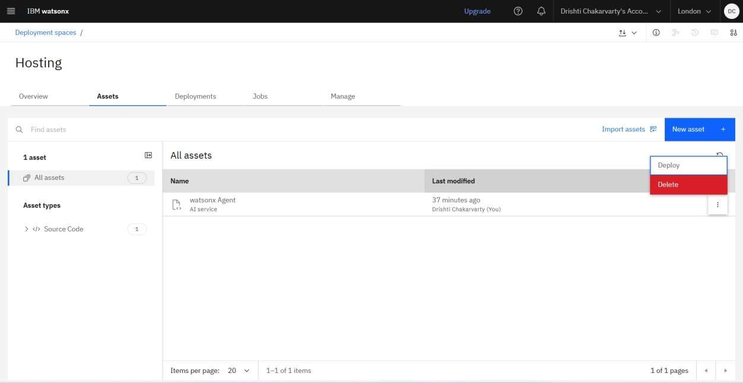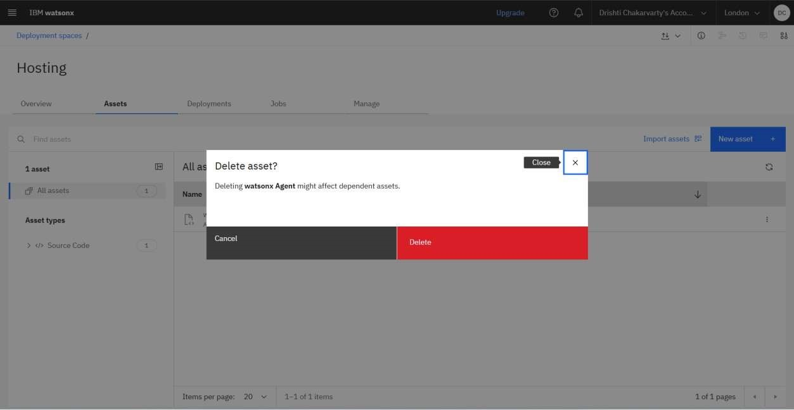

8. Now at the end Delete the previously created deployment space.

9.

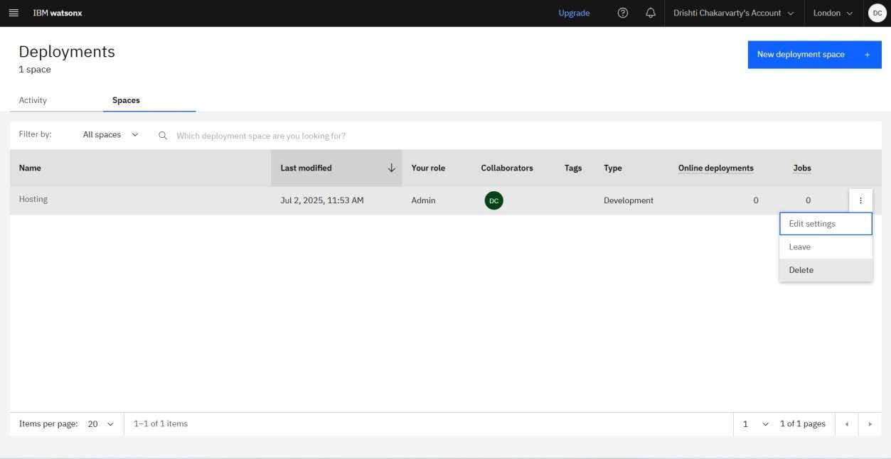

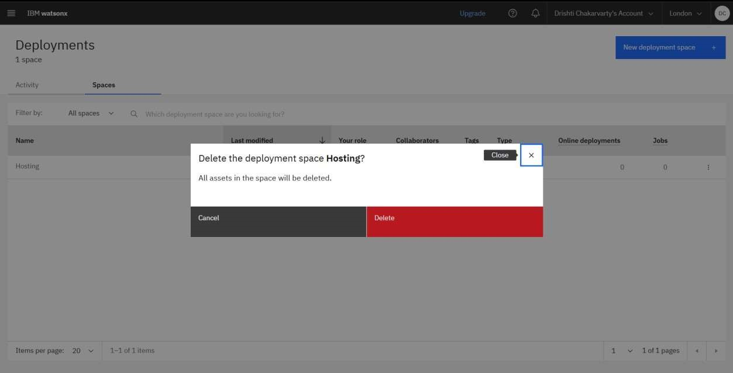

Step-41 Now give the name to your deployment space and then click on Create.

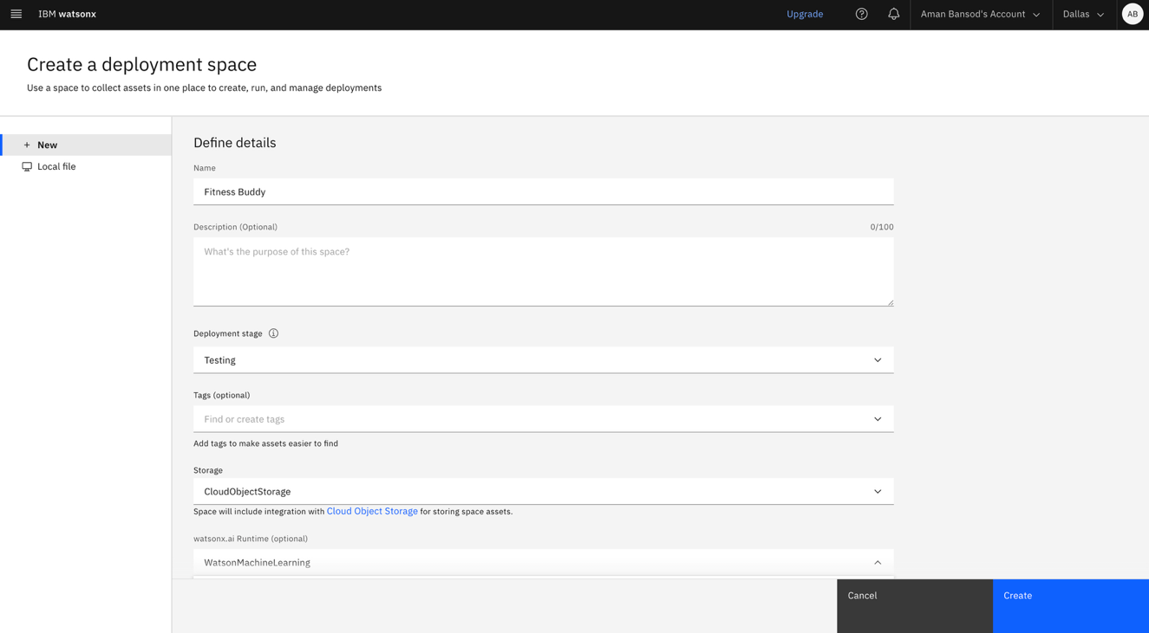

Step-42 You will get a pop-up displaying The space is ready.

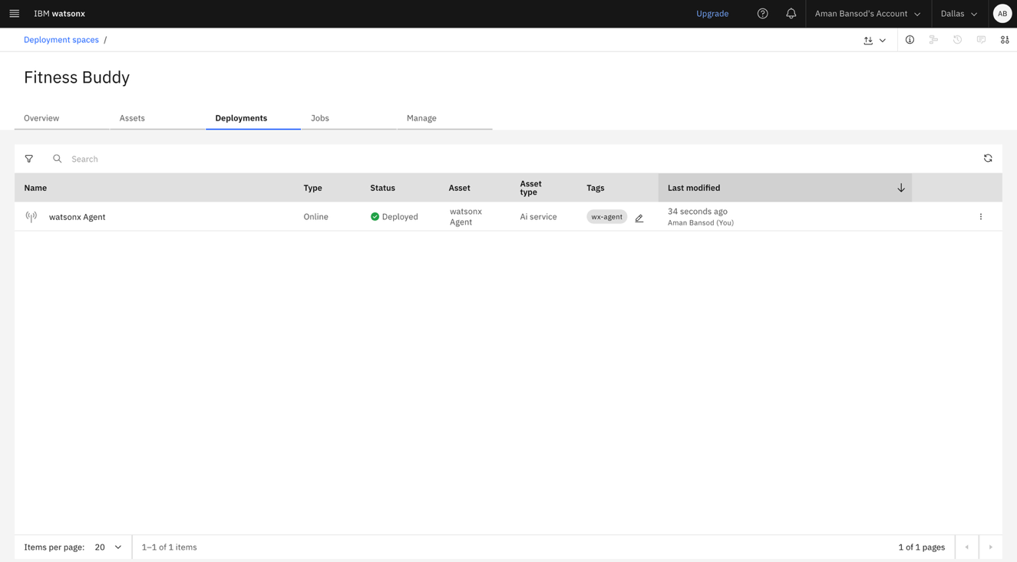

Step-43 Go back to the Deployment space and the click on Reload.

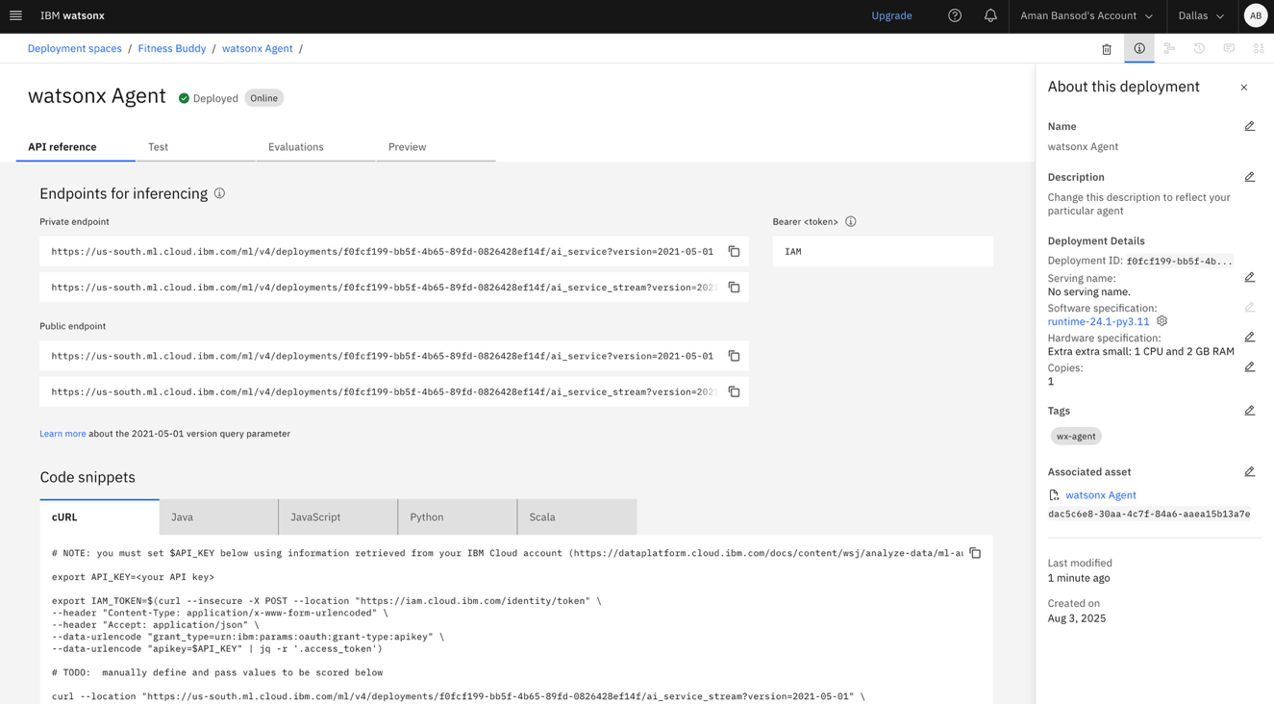

Step-44 Now click on Deploy.

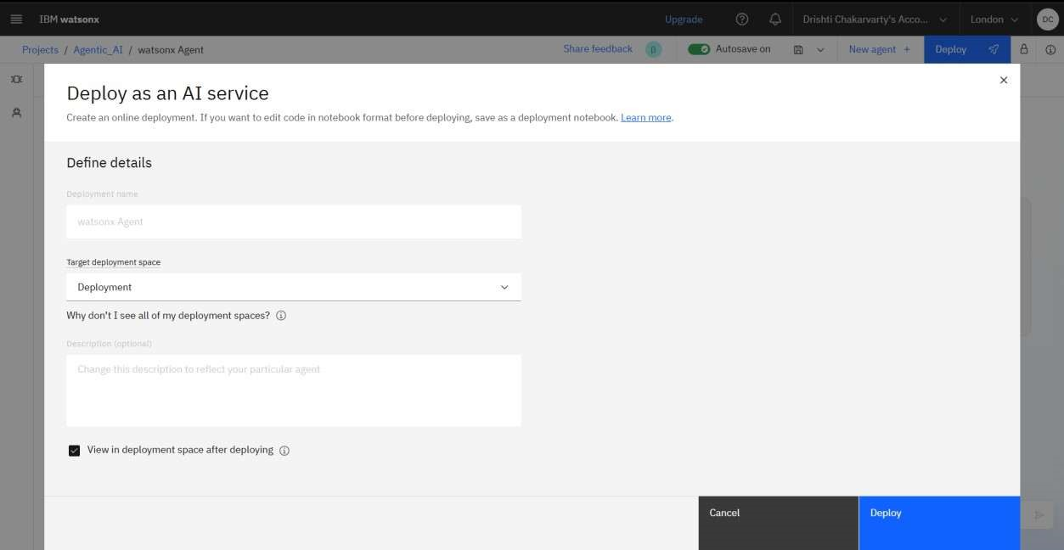

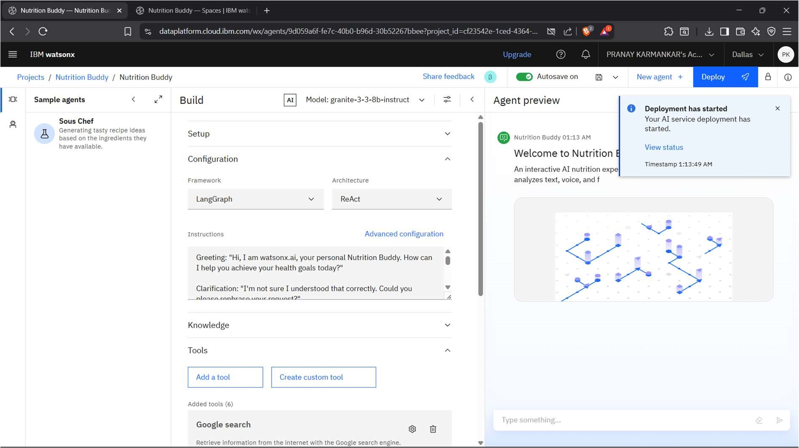

Step-46 You will see that your agent is ge ng deployed.

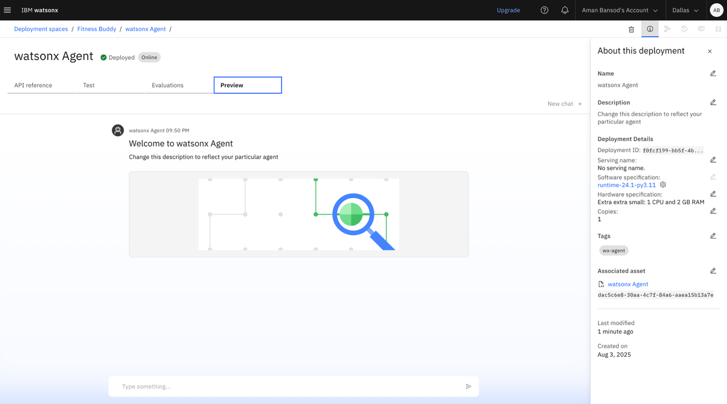

Step-47 You can see that your agent is successfully deployed, now click on watsonx Agent.



Step-48 You can see the API references for your Deployed agent.



Step-49 Now you can click on Preview and ask ques ons to your agent.

